cnc_upload4

声明
/* upload NC program 4 */
[DllImport("FWLIB32.dll", EntryPoint = "cnc_upload4")]
public static extern short cnc_upload4(ushort FlibHndl, ref int a, [Out, MarshalAs(UnmanagedType.AsAny)] Object b);

描述
程序传输：从CNC到计算机。
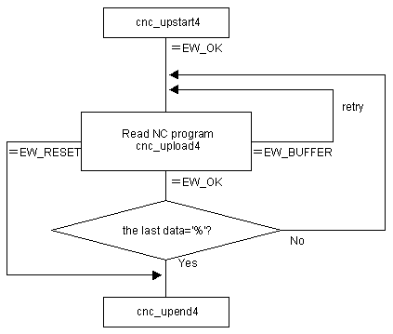

参数
（1）FlibHndl 库句柄；[ in ]
（2）length 长度 [ in/out ]
（3）data 程序 [ out ]

函数返回值
函数运行正常返回EW_OK。
Return code | Meaning/Error handling
EW_RESET  (-2) | Reset or stop request  The data to read is nothing.  Call the cnc_upend4 function.
EW_FUNC  (1) | cnc_upstart4 function has not been executed.
EW_LENGTH  (2) | The size of character string is less than 256.
EW_DATA  (5) | Data error  In order to get more information for this err_no return value, execute cnc_getdtailerr function.  The following detail status will be set onto the member, err_no of ODBERR structure.  See Description about the timing of error.
  2 | : | Program is not found within the specified range.
  3 | : | NC program memory is broken.
EW_PROT  (7) | Protected  Tape memory is read-protected by the CNC parameter setting(O8000-/O9000- protection, encoding).  See Description about the timing of error.
EW_BUFFER  (10) | Buffer empty/full  Retry because the buffer is empty.  See Description about the timing of error.

代码
class Program
{
static void Main(string[] args)
{
ushort Flibhndl = 0;

short ret; // 返回值

// 获取库句柄 ( Ethernet )
ret = Focas1.cnc_allclibhndl3("192.168.0.224", 8193, 10, out Flibhndl);
if (ret != Focas1.EW_OK)
{
Console.WriteLine("发生异常，请检查！");
return;
}

#region cnc_upload4

string str = "";
string prgname = Console.ReadLine();
byte[] buf = new byte[1280]; // String of CNC program
int len ;
ret = Focas1.cnc_upstart4(Flibhndl, 0, prgname);// "//CNC_MEM/USER/PATH1/prgname"
if (ret != Focas1.EW_OK) return ;
do {
len = 1280 ;
do
{
ret = Focas1.cnc_upload4(Flibhndl, ref len, buf);
} while (ret == 10);

if ( ret == Focas1.EW_OK )
{
for (int idx = 0; idx < len; idx++) str += Convert.ToString(Convert.ToChar(buf[idx]));
}
if ( buf[len-1] == '%' )
{
break ;
}
} while ( ret == Focas1.EW_OK ) ;
ret = Focas1.cnc_upend4(Flibhndl);
Console.WriteLine(str);

#endregion
}
}

